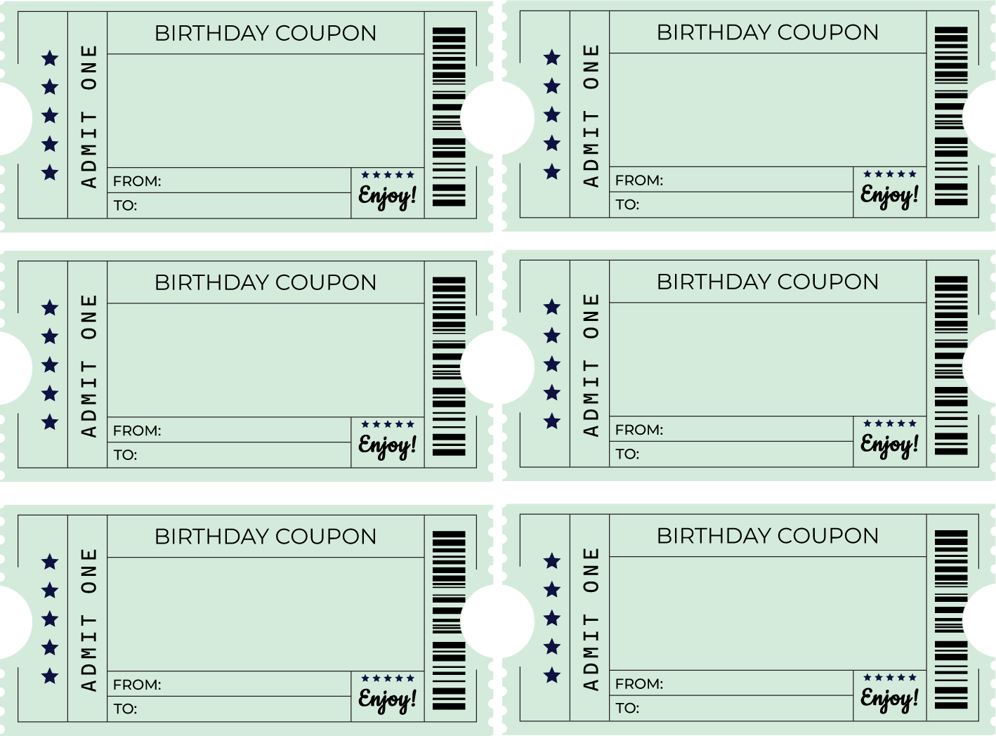

Make your fav
dessert
Win argument

Build a fort
Chore free day

10 min
massage
Choose dinner

