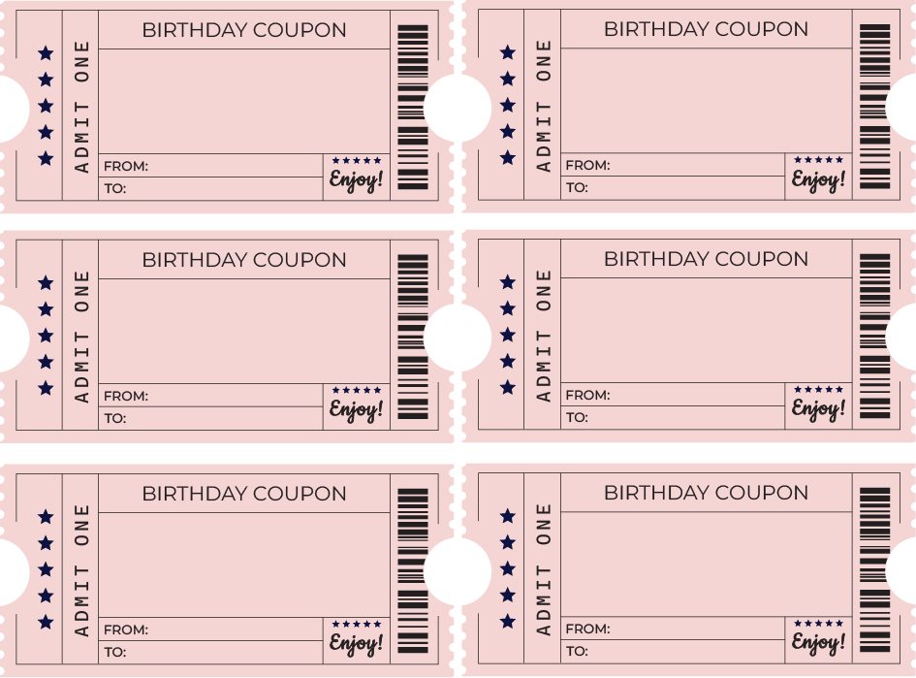

Ice cream
Just us day

Homework done!
Movie night

Shopping Adventure!
Picnic day

